Part1

1. Update the system packages:

- Ubuntu/Mint:

```bash

sudo apt update && sudo apt upgrade -y

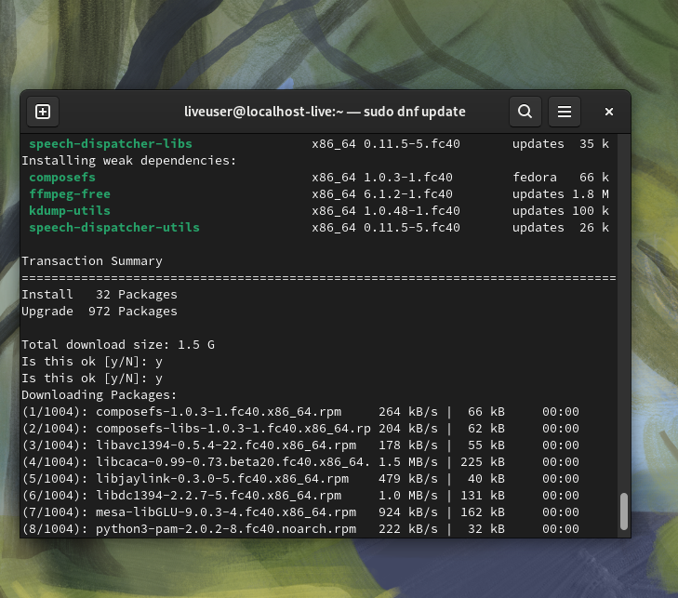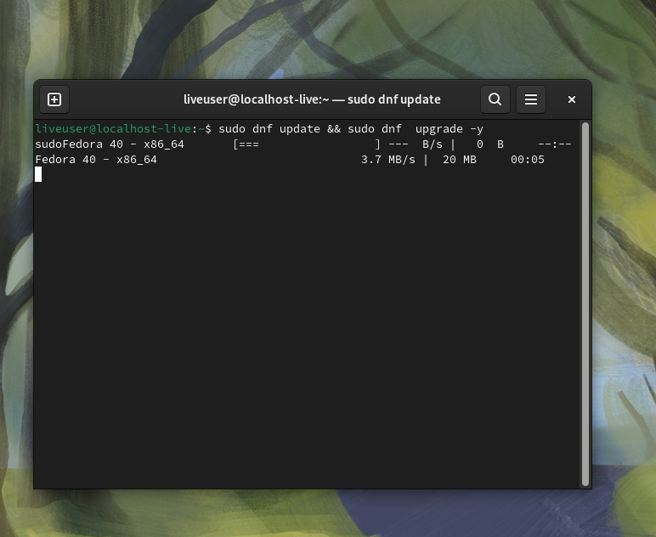

Updating packets:

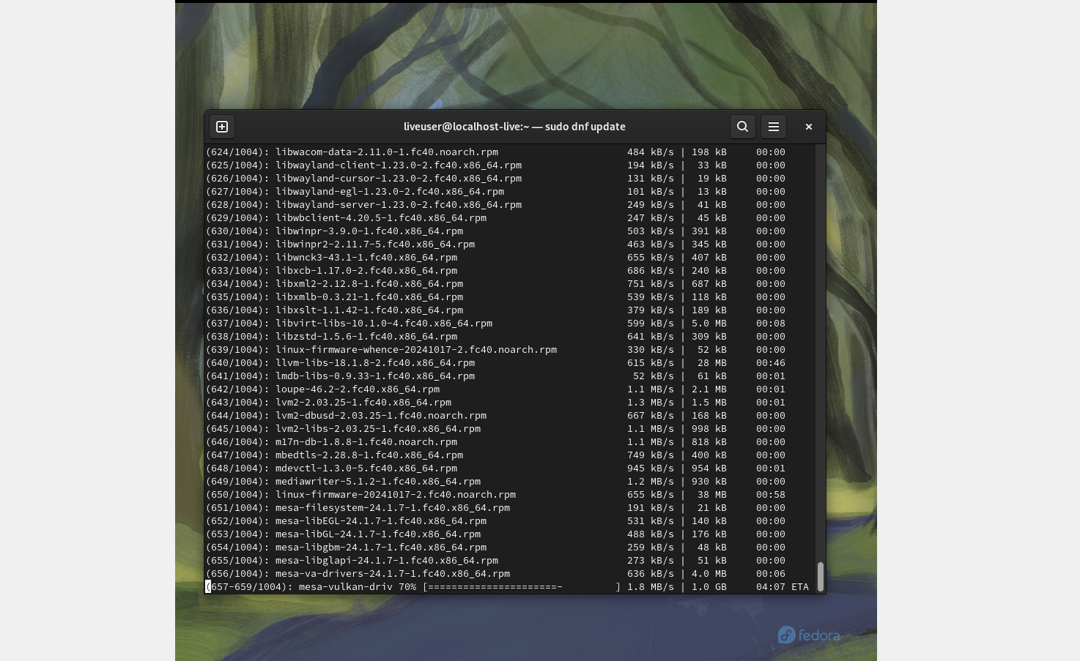

2. Ensure that a valid hostname is set:

- Use the following commands to set and verify the server’s hostname:

```bash

sudo hostnamectl set-hostname mail.example.com

hostnamectl

```

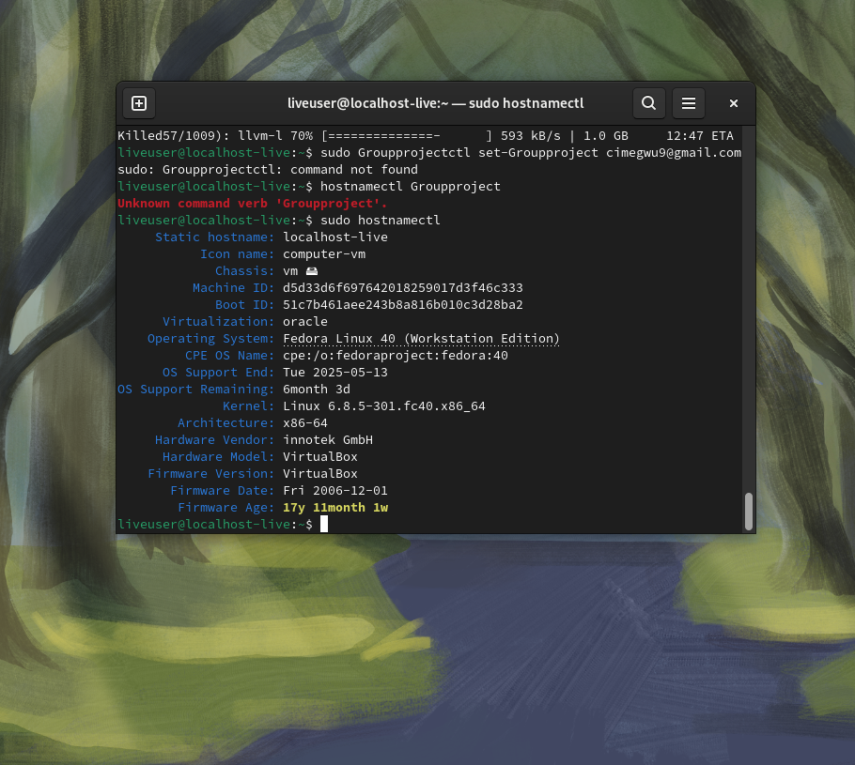

1. Install Postfix, Dovecot, MySQL, and necessary tools:

- Ubuntu/Mint:

```bash

sudo apt install postfix postfix-mysql dovecot-core dovecot-mysql dovecot-pop3d dovecot-imapd mysql-server mysql-client clamav clamav-daemon amavisd-new

```

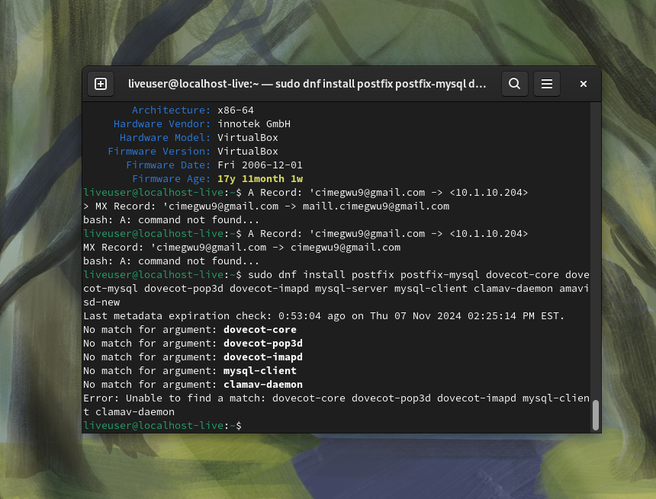

2. Enable and start services:

```bash

sudo systemctl enable postfix dovecot mysql clamav-daemon amavis

sudo systemctl start postfix dovecot mysql clamav-daemon amavis

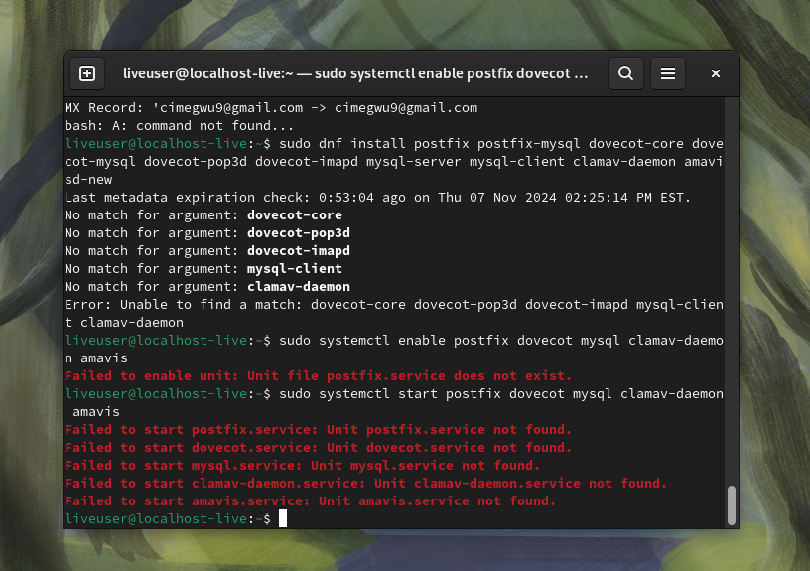

1. Create the MySQL database and tables:

- Log in to MySQL and create the `mailserver` database:

```bash

sudo mysql -u root -p

CREATE DATABASE mailserver;

```

2. Create the necessary tables for storing virtual domains, users, and aliases:

```sql

CREATE TABLE `virtual_domains` (

`id` int(11) NOT NULL auto_increment,

`name` varchar(50) NOT NULL,

PRIMARY KEY (`id`)

);

CREATE TABLE `virtual_users` (

`id` int(11) NOT NULL auto_increment,

`domain_id` int(11) NOT NULL,

`password` varchar(255) NOT NULL,

`email` varchar(100) NOT NULL,

PRIMARY KEY (`id`),

UNIQUE KEY `email` (`email`)

);

```

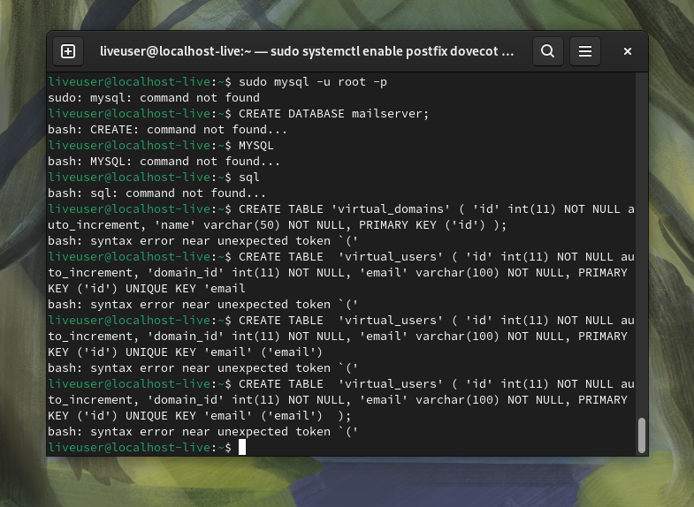

3. Create a MySQL user for Postfix to interact with the database:

```sql

GRANT SELECT ON mailserver. TO 'mailuser'@'localhost' IDENTIFIED BY 'secure_password';

FLUSH PRIVILEGES;

```

